MFANZ Interface Control System Project

Overview

Last Saved: 6/30/2007 02:23:00 AM

Table of Contents
Table of Contents 2
Document Purpose 3
Background 4
Objectives 4
ICS – Interface Control System 5
ICS - User Interface 6
LICS – Local Interface Control System 7
Inbound interfaces 7
Outbound interfaces 7
Pass through interfaces 7
Triggered interfaces 7
Splitting interfaces 7
Event logging 8
Notification 8
Purging 8
General Procedures 8
Transport Mechanisms 8
Appendix 9
Data Interface Issues 9
Atlas - Data Interface Issues 9
Local Atlas Data Store - Data Interface Issues 10
Interface Control System Detailed Diagram 13
Atlas - Lads Dataflow Diagram 14
Atlas - Lads Dataflow Diagram 15

Document Purpose

Provides a high level functional overview of the Interface Control System (ICS), including interfaces, transport mechanisms and basic data (LADS) operations. At the end of the document there are several overview diagrams that gradually increase in complexity.

Project Description

Background

Atlas is being implemented into Master Foods Australia New Zealand (MFANZ). The process of implementation requires a central repository of relevant Atlas information that can service all MFANZ legacy systems.

Objectives

The key objective of this project is to provide a central repository of relevant Atlas information and the infrastructure to move this data between Atlas and any legacy systems. The architecture of this solution must facilitate the switching off of legacy systems as they become redundant.

ICS – Interface Control System

The design concept of the Interface Control System is to encapsulate the complexity of the data interface functionality in a single place and to provide a central point of reference for support issues. The system is made up of the following:

- The Local Interface Control System that provides the infrastructure for processing interface files between Atlas and downstream legacy systems.
- The Local Atlas Data Store that provides a central store of Atlas information that can be accessed by all legacy systems.
- Central Legacy Systems that provide a central store of legacy information that can be accessed by site legacy systems.

The Interface Control System facilitates:

- The centralised storage of interface information.
- The centralised development of interface processing.
- The centralised notification of interface exceptions.
- A single point of reference for interface support issues.
- The ability to easily switch off legacy systems as they are replaced by 2005 systems.
- The servicing of legacy servers that do not support Maestro and Data Junction.

The Interface Control System database consists of the following schemas:

- The LICS schema – this schema contains the interface control tables.
- The LADS schema – this schema contains the Atlas data tables.
- The CUST schema – this schema contains any central legacy customer information.
- The MATL schema – this schema contains ant central legacy material information.
- The VEND schema – this schema contains any central legacy vendor information.
- The MANU schema – this schema contains any central legacy manufacturing information.
- The SALE schema – this schema contains any central legacy sales information

ICS - User Interface

The ICS user interface will allow authorized users to monitor and review information within the ICS database. The facility will be implemented as an intranet application using standard MARS web security. This facility will provide the following:

- The ability to monitor activity within the ICS database.
- The ability to review the status of individual interfaces and procedures.
- The ability to review any exceptions related to individual interfaces and procedures.
- The ability to resend interface files where data is lost inside the transport mechanism.
- The ability to configure new and existing ICS interfaces
- The ability to stop/start interface processing

LICS – Local Interface Control System

The Local Interface Control System provides the framework for processing interface files between Atlas and downstream legacy systems. The functional areas of this system are:

Inbound interfaces

This area covers interfaces that are inbound into ICS. They are:
- Interfaces from Atlas to ICS.
- Interfaces from legacy systems to ICS.

Outbound interfaces

This area covers interfaces that are outbound from ICS. They are:
- Interfaces from ICS to Atlas.
- Interfaces from ICS to legacy systems.

Pass through interfaces

This area covers interfaces that are passed through ICS to another system. They are:

- Interfaces from Atlas to legacy systems.
- Interfaces from legacy systems to Atlas.
- Interfaces from legacy system to legacy system.

Triggered interfaces

This area covers interfaces that are Inbound to ICS that execute a legacy application stored procedure on a separate processing thread. This functionality allows:

- Legacy stored procedures to execute for extended periods of time without impacting the flow of interfaces through ICS.
- The development and ongoing maintenance of these procedures is under the control of the support team owning the interface (e.g. Site Teams), and not the ICS support team.

Splitting interfaces

This area covers interfaces that are Inbound to ICS that need to be split into multiple outbound files. Splitting is based on configuration, whereby the following variations are available:

- WHEN_START_WITH - starts a new outbound interface when the current inbound data row starts with the comparison string (comparisons are always made in uppercase).
- WHEN_SAME_SUBSTRING - starts a new outbound interface when the substring portion of the current inbound data row is NOT the same as the substring portion of the previous inbound data row.
- FOR_EACH_ROW - starts a new outbound interface for each inbound data row (i.e. if the inbound interface has 100 data rows then 100 outbound interfaces will be created).

Event logging

This area covers the recording of interface events for monitoring and exception purposes.

Notification

This area covers the sending of emails and operator alerts when exceptions occur in the interface control system.

Purging

This area covers the purging of data from ICS. All purging is parameter driven by interface type and includes the following:

- Interface data
- Event information
- Exception information

General Procedures

This area covers the execution of general procedures such as:

- The purging of data from LADS.
- The monitoring of LADS data for integrity. For example, materials without classification information required by legacy systems.

Transport Mechanisms

The system supports the sending and receiving of interface files using the following transport mechanisms:

- Maestro and Data Junction. All interfaces inbound from and outbound to Atlas will be transported via this mechanism.
- MQ/Series. This mechanism will be used where the legacy system supports MQ/Series.
- FTP. This mechanism will be used where the legacy system only supports FTP access.
- Direct Oracle connections via database links. This mechanism can be used by legacy systems running in an Oracle environment to invoke outbound loader interfaces.

Appendix

Data Interface Issues

Atlas - Data Interface Issues

The existing mechanism for interfacing information from the Atlas system to legacy systems has resulted in a number of issues that can cause data integrity and processing problems on the legacy systems. These issues can be summarized as follows:

- Information sent but not received.
Target Table

Data update 1
Data update 2
Data update 4
Atlas

Sends various data updates:

Data update 1
Data update 2
Data update 3
Data update 4
HUB

Data update 1
Data update 2
Data update 3
Data update 4

Data update 3 is rejected in the HUB
Target System

1) Receives
Data message 1
Data message 2
Data message 4

- Information sent in one sequence and received in another.
Target Table

Data reflects data update 1
Atlas

Sends data update 1 and 2 for the same material in the correct sequence. That is, update 1 occurred before update 2.
HUB

The HUB forwards the data updates in the following sequence:

Data update 2
Data update 1
Target System

1) Receives data update 2 and applies to target database.

2) Receives data update 1 and applies to target database.

- Logical groups of information sent as unrelated individual data updates.

Target Table

Data update 1
Data update 2
Data update 3
Data update 4
Target Table

Data update 5
Data update 6
Atlas

Sends logical group of data updates 1 to 6
HUB

Data update 1
Data update 2
Data update 3
Data update 4

NETWORK DELAYS

Data update 5
Data update 6
Target System

1) Receives
Data update 1
Data update 2
Data update 3
Data update 4

2) No activity for 30 minutes
Clears target table
Loads data

3) Receives
Data update 5
Data update 6

4) No activity for 30 minutes
Clears target table
Loads data

Local Atlas Data Store - Data Interface Issues

The Local Atlas Data Store will be used as a central repository of relevant Atlas information for all MFANZ legacy systems. The integrity of the information stored in this database is critical to the operation of these legacy systems, especially factory processing systems where erroneous interface data could cause production problems. There are some existing data interface issues that will need to be addressed and resolved before the integrity of the new Local Atlas Data Store could be guaranteed. These issues are:

- The HUB does not guarantee sequence of delivery. In the near future, sometime in 2004, the HUB is converting to a parallel processing model that will, in all probability, increase the occurrence of sequencing problems significantly.
- The Atlas default is to send interface information at the transaction level only. This means that the delivery of logical groups of information, for example customer hierarchies, cannot be reliably dealt with by the target systems as they have no way of knowing when the entire group has been received. This has caused problems in existing downstream systems where time delays have been used in an attempt to determine the completion of a group interface. When data is delayed in the HUB for unforeseen periods of time this mechanism has failed and subsequently caused data integrity and processing problems in these downstream systems.
It is essential that the following design concepts must be incorporated into Atlas interfaces and any downstream systems that are reliant on Atlas and the HUB for delivery of information.

- For each single data message sent from the Atlas system the message must contain the following information:

  - A transaction type that indicates the type of data being sent.
  - A transaction timestamp that reflects the sequence that the data was applied to the Atlas database.
- For each group data message sent from the Atlas system the message must contain the following information:

  - A transaction type that indicates the type of data being sent.
  - A group identifier that uniquely identifies the group.

- For each group sent from the Atlas system an additional data message (group control message) must be sent containing the following information:

  - A transaction type that indicates a group control message.
  - A group identifier that uniquely identifies the group.
  - A group timestamp that reflects the group creation date and time.
  - The total count of all data messages within the group.

- For singleton updates at the target system, the Atlas transaction timestamp will need to be compared to the previously maintained timestamp held on the target system. Only interfaced updates with a timestamp greater than the local version timestamp will be processed. The data should be sourced from the same database to ensure the integrity of the timestamps. The message data must contain logical row data only, not column changes; otherwise sequencing becomes impossible without storing local timestamps against columns.
- For singleton updates at the target system, the target system will need to deal with orphans caused by out of sequence delivery. Orphans will need to be cached in temporary storage until their parent arrives. As each parent arrives the process will need to check for any orphans in the cache and deal with them appropriately. The orphan cache will need to be monitored for orphans that have resided in the cache for an unacceptable period of time. These long term orphans will need to be raised as exceptions for resolution.
- For singleton updates at the target system, a data message sent from the source system may never arrive at the target system. This situation can occur when cross reference validations fail within the HUB. It is impossible to cater for this situation. Therefore, for each singleton update process there will need to be a group update process that can be invoked periodically to refresh the downstream system.
- For group updates at the target system, the source system will need to send a group control message that indicates the number of messages sent within the group. The group control message can be sent as either a header or trailer, which ever is more suitable for the source system. The target system must deal with this group control message regardless of arrival sequence. The target system would need to check the group control count as each group message was received. Only when the received count matches the group control count can the group processing take place at the target system. The group message cache would need to be monitored for incomplete group updates that have not completed for an unacceptable period of time. These incomplete group updates will need to be raised as exceptions for resolution.

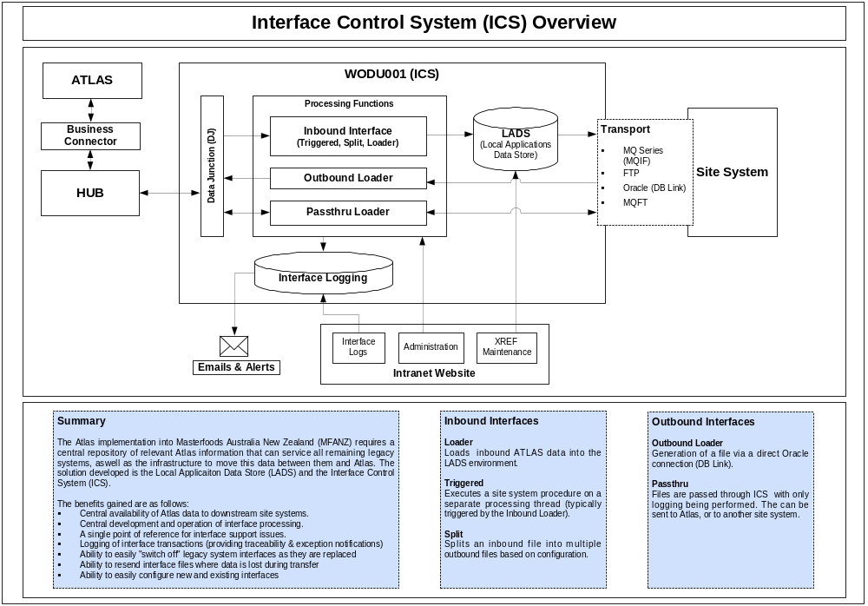

Interface Control System Detailed Diagram
INBOUND
PROCESSOR
PACKAGE
LADS/Legacy
Inbound
Procedure
LADS/Legacy
Tables
Send UNIX Script
Interface Files
OUTBOUND
LOADER
PACKAGE

LADS/Legacy
Outbound
Procedure
LADS/Legacy
Tables
OUTBOUND
PROCESSOR
PACKAGE
Events
Exceptions
Interface
Header
Interface
Data
(Inbound Only)
ORACLE JOBS
ORACLE JOBS
INTRANET
USER
INTERFACE
TRANSPORT

Data Junction
MQ/Series
FTP

Emails &
Operator
Alerts
INBOUND
UTILITY
PACKAGE

(Add Exception)
PASSTHRU
LOADER
PACKAGE
INBOUND
LOADER
PACKAGE
Receive UNIX Script
PASSTHRU
PROCESSOR
PACKAGE
ORACLE JOBS
Atlas – Legacy Interface Dataflow Diagram
MFANZ – INTERFACE CONTROL SYSTEM SERVER
ATLAS SERVER
MFANZ - LEGACY SERVERS
SNAPSHOTS / VIEWS / INTERFACES
LADS INFORMATION

(READ ONLY)
CENTRAL LEGACY SCHEMA #1
(e.g. Common Plant Database)
CENTRAL LEGACY SCHEMA #2

CENTRAL LEGACY SCHEMA #N

LADS SCHEMA
CENTRAL LEGACY SCHEMAS
INTERFACES

HUB
LEGACY DATABASE
LEGACY DATABASE
LEGACY DATABASE

BUSINESS CONNECTOR
CENTRAL LEGACY INTERFACES

DATA JUNCTION

LEGACY SYSTEMS
IDOC
IDOC
ATLAS - UPLOAD
ATLAS - DOWNLOAD

Atlas - Lads Dataflow Diagram
IDOC
IDOC
INTERFACE FILES
LEGACY ORACLE DATABASES
LEGACY DATABASES
MFANZ - LOCAL DATA STORE SERVER
ATLAS SERVER
MFANZ - LEGACY SYSTEMS
MQ/IF
FTP
INTERFACE FILES
INTERFACE FILES
LADS SCHEMA
CENTRAL LEGACY SCHEMAS
SNAPSHOTS
LINKS
UPSTREAM
INBOUND CONTROL
DOWNSTREAM
OUTBOUND CONTROL
DOWNSTREAM
INBOUND CONTROL
UPSTREAM
OUTBOUND CONTROL
CENTRAL LEGACY UPDATE CONTROL

HUB
XML Messages
BUSINESS CONNECTOR
ATLAS - UPLOAD

MAESTRO (DATA JUNCTION)
ATLAS - DOWNLOAD
ORACLE DATABASE

